# DefTrack Workflow

DefTrack software workflow is designed to manage software defect tracking through the following stages:

1. User records new Defect
2. Project Manager reviews submitted defect and assigns priority to the defect
3. Lead Developer reviews defects that were assigned a priority and then assigns the defect to a specific developer.
4. The develop receives the defect and resolves issue
5. The Quality Control group receives all defects marked as ‘resolved’ by the development team.
6. Once QC completes testing the defect is put in “Awaiting Customer Acceptance” status where the Project Manager watches the queue and works with the customer before closing out the defect.

## Record New Defect

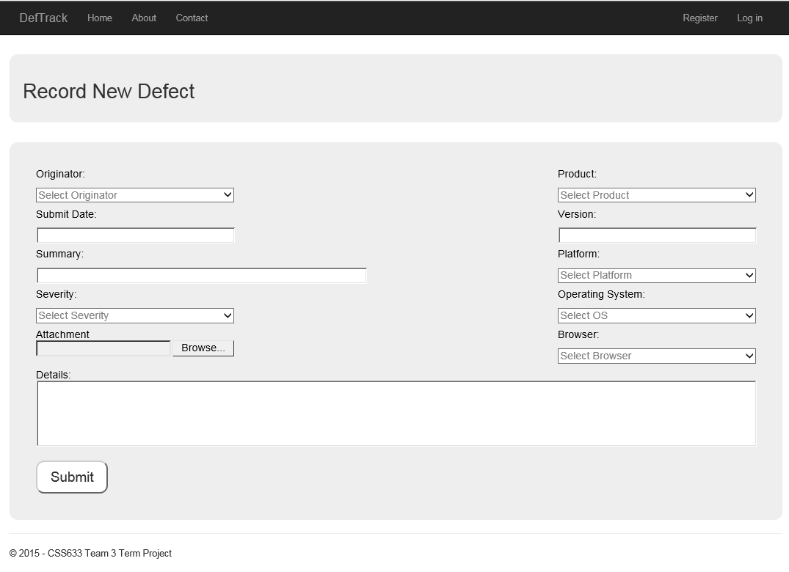

## Project Manager Work Queue

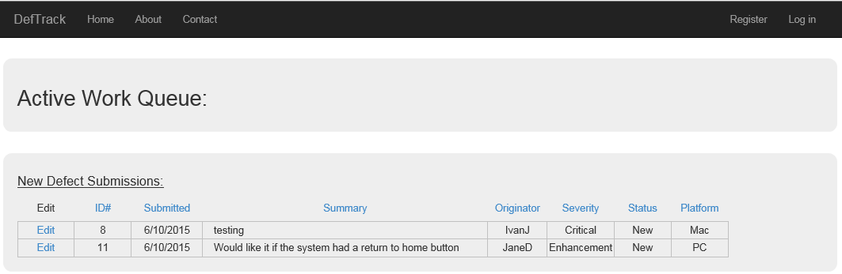

The Project Manager has a queue consisting of all newly submitted defects. The Project Manage clicks on a Defect ID which pulls up the Defect request and from there is able to assign a Priority and add any comments.

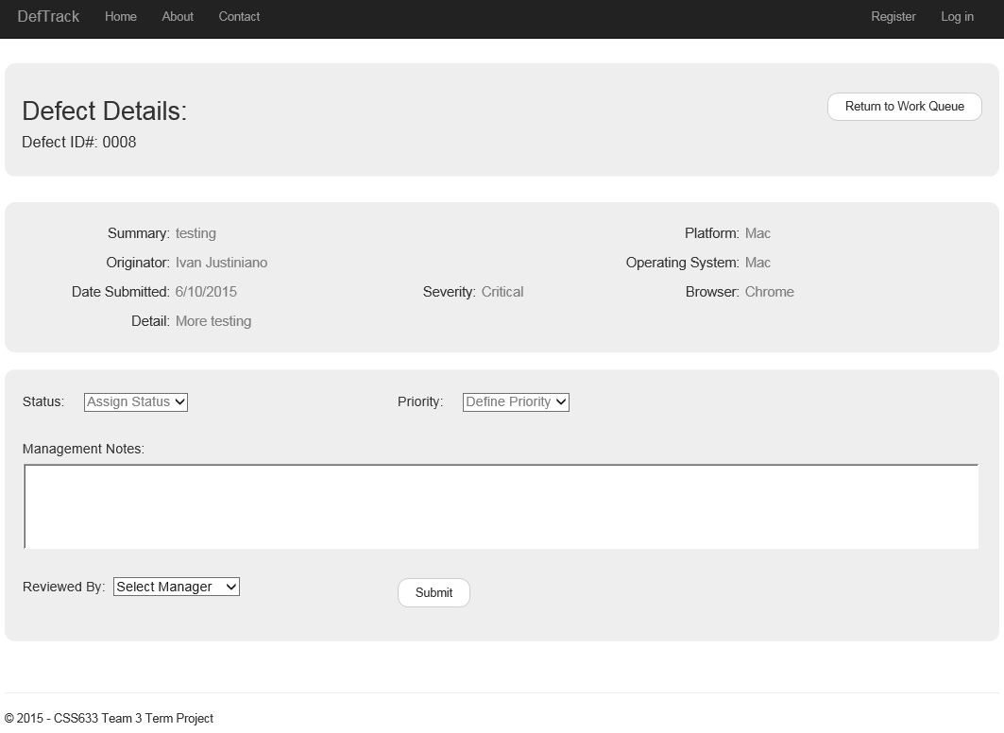

## Lead Developer Work Queue

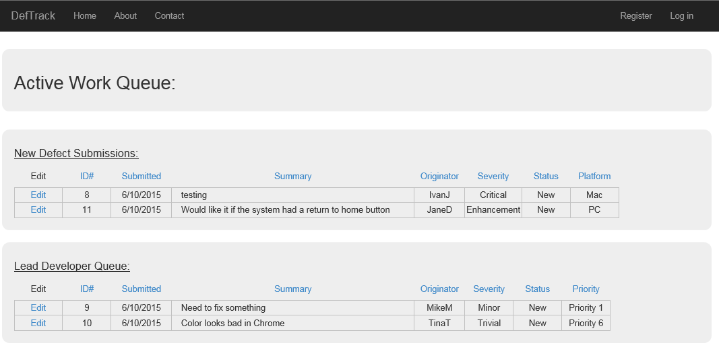

The Lead Developer queue lists all defects that have been approved by the Project Manager and assigned a priority level. The Lead Developer selects a Defect ID and is able to review the original defect request plus the Project Manager Notes.

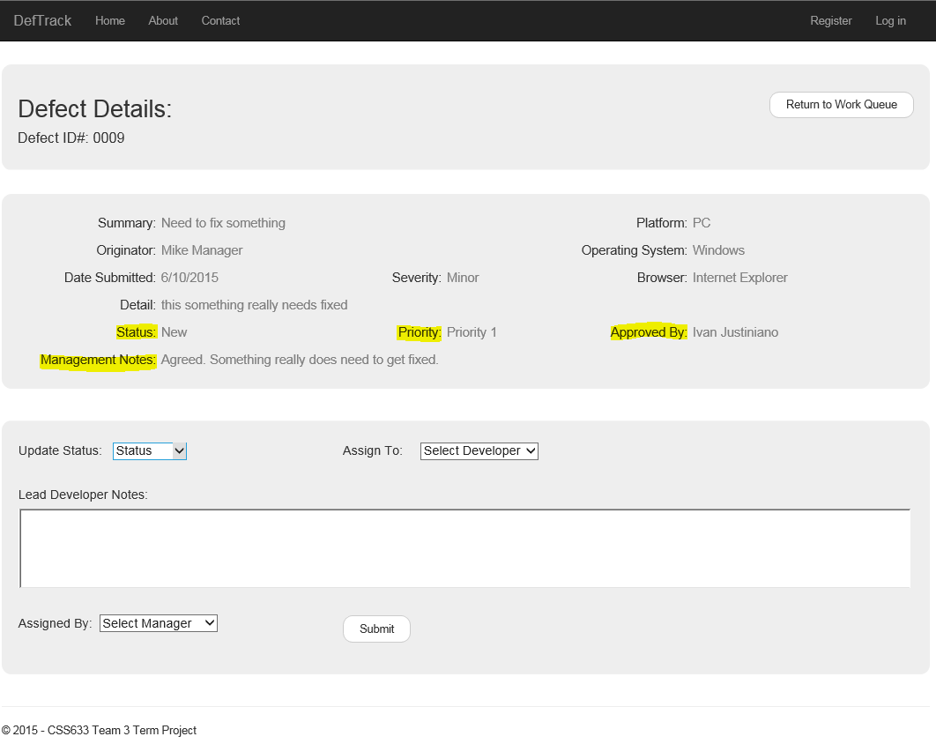

## Developer Work Queue

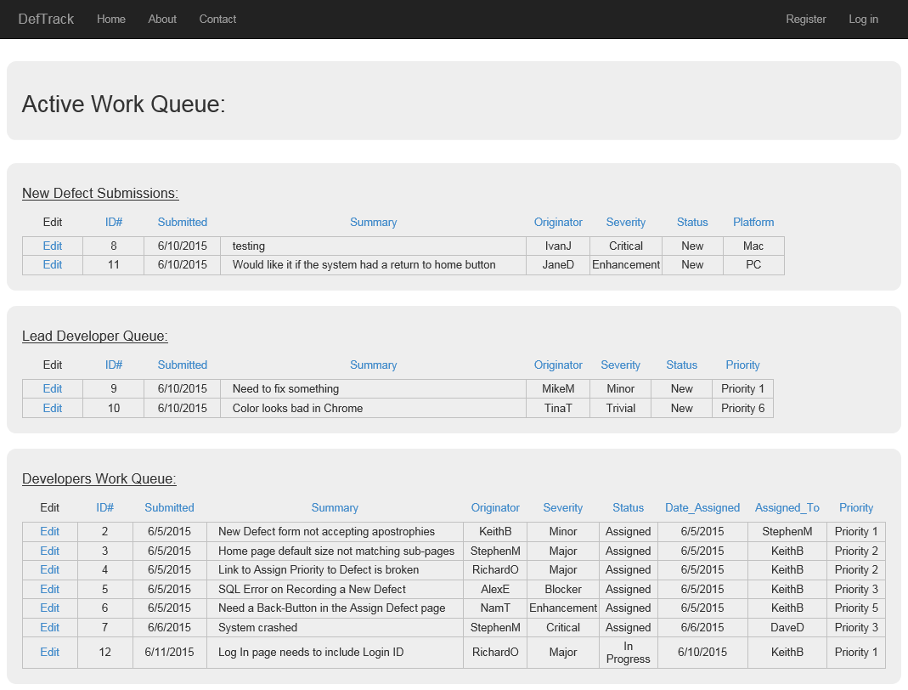

The Developer’s work queue consists of all defects that the Lead Developer has assigned. The work queue can be sorted by any column so that the developer can quickly identify his/her tasks, the priorities, and the severities of all outstanding defects. The Developer would then click on a specific Defect ID and would view all details of the defect.

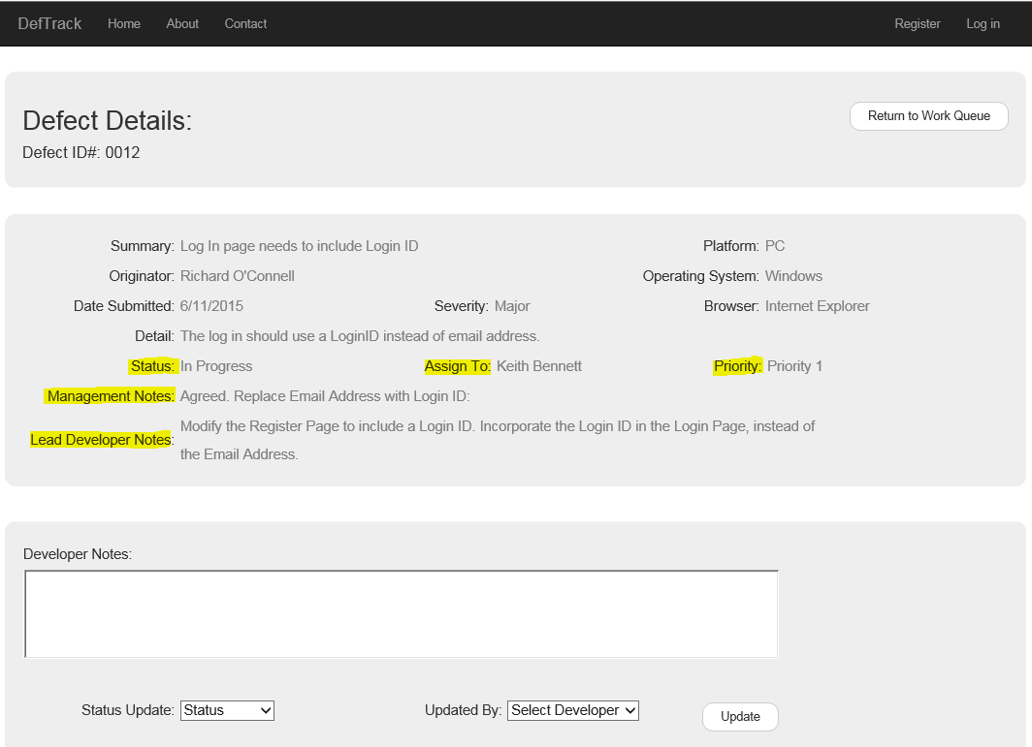

As the Developer works on the defect and updates comments to the DefTrack system, the comments will display in chronological order.

## Quality Control Queue

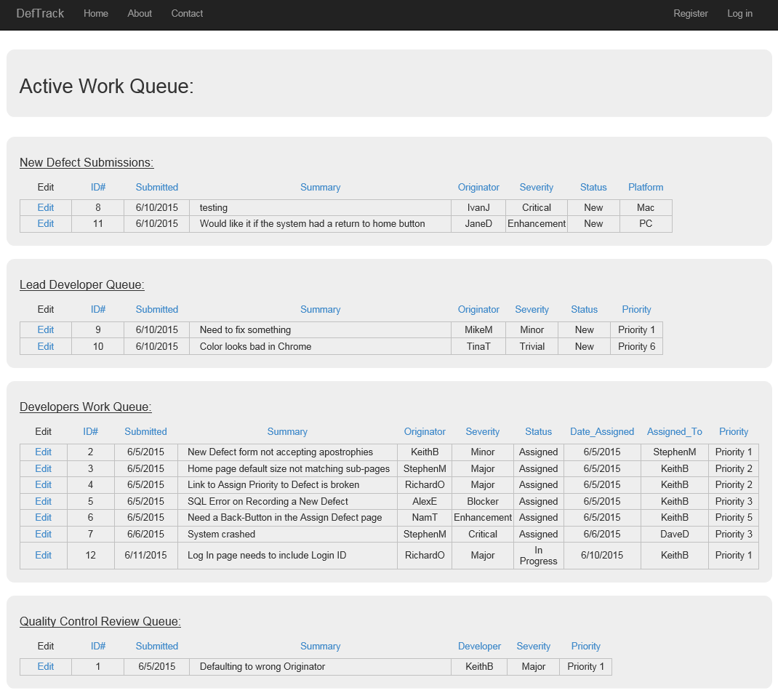

The Quality Control group has a work queue that includes all defects that the Developer has set a status of “Resolved”. The Quality Control group reviews each defect, defines a test plan, documents their testing, and either marks the defect as:

* Awaiting Customer Acceptance – QC found defect to be resolved and is forwarding it back to the customer for validation.
* Re-Opened – QC found defect to fail testing and is being sent back to the Developer’s work queue.

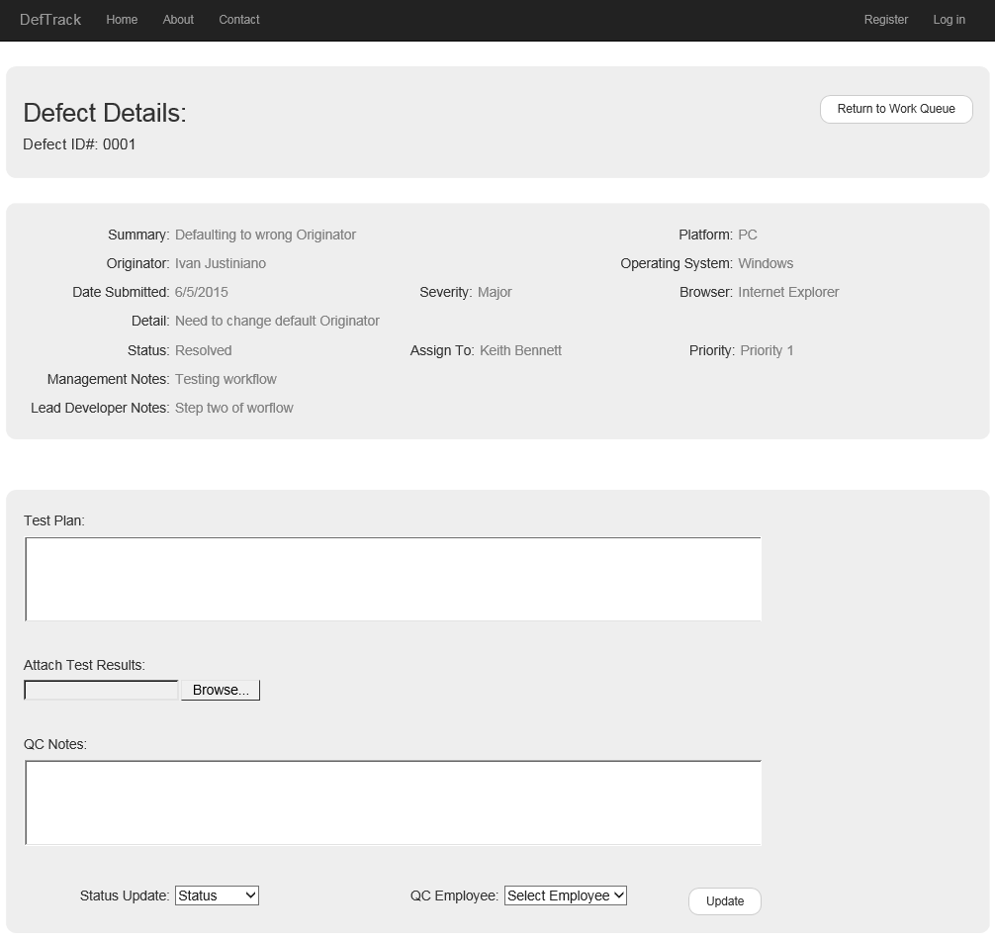

The QC Detailed view above will include all notes from the Developer.

## Final Review Queue

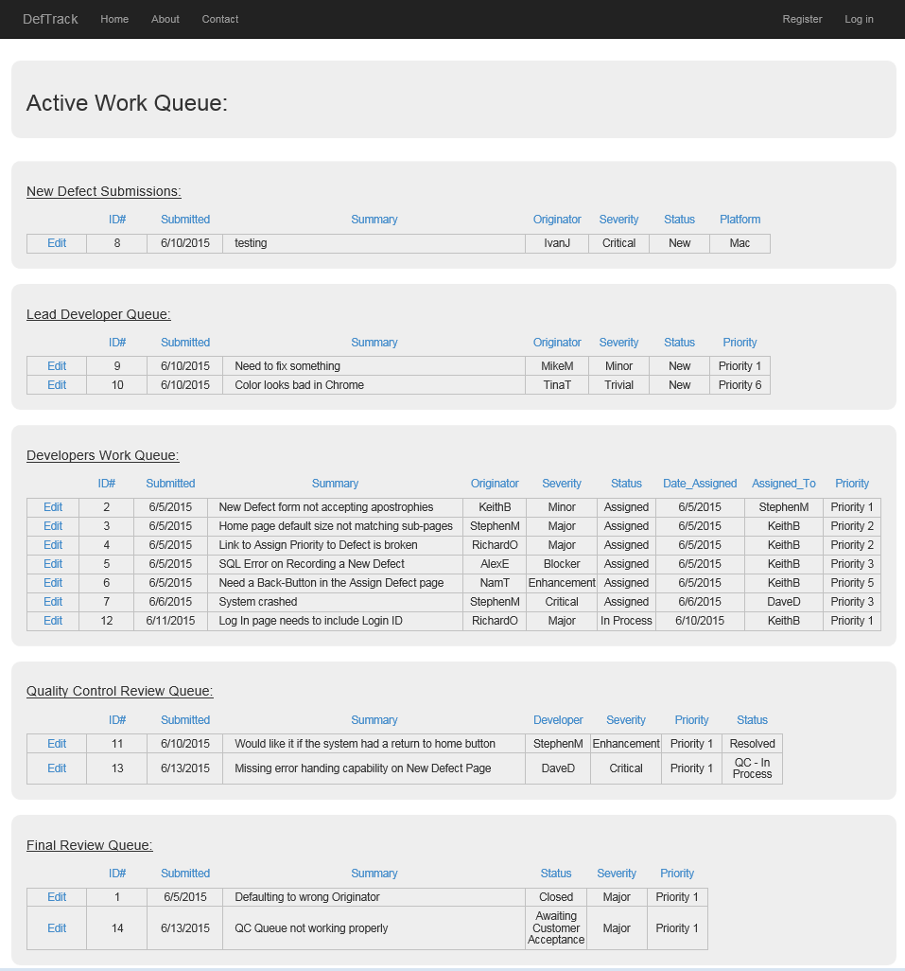

The final queue of the DefTrack system is the queue that holds the following defects.

* Status = ‘Rejected’ – These are defects that the Project Manager denied at the beginning
* Status = ‘Awaiting Customer Response’ – These are defects that Quality Control has successfully completed testing and the customer has been notified for final review and acceptance.
* Status = ‘Closed’ – These are defects that either the customer has accepted and the defect was closed out, or there was no response from customer and the project manager went into queue and closed out the defect ticket.

The defects in this queue can be opened and all notes and documentation will be available. The Project Manager will have the ability to update the status to a “Closed” status when either the customer acknowledges acceptance of the resolution or there is no response from customer and project manager is cleaning up the queue.

